Overview:
This project is a place-focused website dedicated to showcasing Guatemala, designed to educate and inspire visitors by answering the question: “Do you know Guatemala?” The site will highlight the country’s rich history, vibrant culture, and breathtaking landscapes through an engaging, interactive experience. Users will explore high-quality images, historical facts, and travel tips, supported by dynamic features like an interactive map and curated content from public APIs.
Target Audience
-Travelers & Tourists: People planning to visit Guatemala and looking for attractions, maps, and tips.
-Culture Enthusiasts: Users interested in history, traditions, and cultural heritage.

Major functions

Dynamic Navigation Menu
The website will feature a dynamic navigation menu that automatically adapts based on the user’s device and scroll behavior. It will include smooth transitions, active section highlighting, and quick access to major site categories such as Places, Culture, Food, History, and Gallery.

Interactive Maps with Locations (Google Maps API / Mapbox)
Users can explore Guatemala through an interactive map that displays location markers for tourist attractions, historical sites, cultural regions, and natural wonders. Clicking a marker will open a dedicated info panel with descriptions, routes, and nearby recommendations.

Public API Integrations
The application will incorporate three main public APIs to enhance user experience:
- YouTube Data API: Embed local music, cultural videos, and travel clips associated with each location.
- Google Maps API or Mapbox: Provide map navigation, routes, and geographic visualization.
- Unsplash API: Fetch high-quality, curated images corresponding to specific cities, landmarks, or cultural themes.

Educational Content Sections (History, Culture, Traditions)
The site will include structured information sections that teach users about Guatemala’s history, cultural diversity, indigenous groups, traditions, and national symbols. Each topic will be presented using visuals, timelines, and interactive elements.Detailed Place Information Pages
Each major Guatemalan location—such as Antigua, Lake Atitlán, Tikal, Semuc Champey, and major volcanoes—will have its own page. These pages will include:
- Description of the place
- Historical background
- Key attractions
- Travel recommendations
- Images retrieved from Unsplash
- Embedded related videos via YouTube API

Traditional Food Section
The site will feature a dedicated area showcasing traditional Guatemalan foods such as pepián, kak’ik, tamales, rellenitos, fiambre, and more. Each dish will include:
- A short description
- Region of origin
- Cultural importance
- Ingredients and presentation
- Optional gallery or embedded video

Media Gallery and Image Viewer
A curated multimedia gallery will display high-quality images of Guatemala’s landscapes, people, foods, and culture. Users can browse by category, open images in a lightbox viewer, and explore photographer credits fetched dynamically using the Unsplash API.
Animated Cards and Interactive UI Elements
The application will use engaging animations to enhance the user experience. Place cards, food cards, and cultural topic cards will feature:
- Hover effects
- Smooth transitions
- Flip animations
- Fade-in or slide-in effects on scroll
These animations help make the interface modern, visually appealing, and interactive.

Wireframes
Desktop
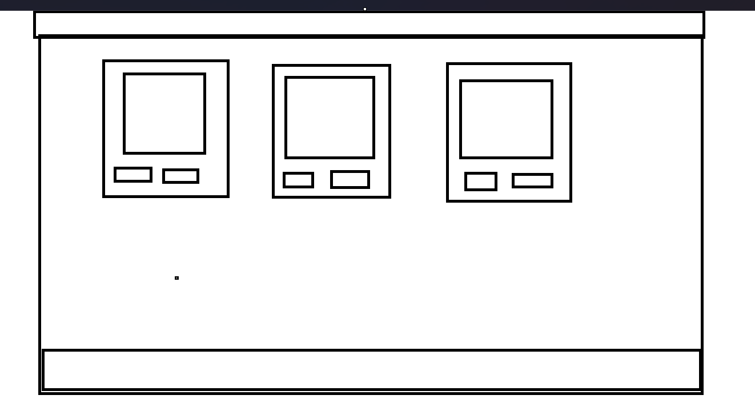

Mobile
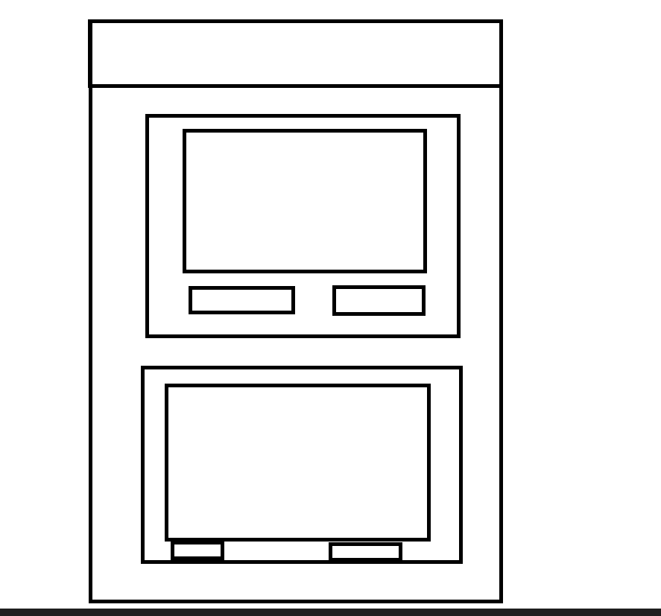

Public Apis:
-YouTube Data API: Embed music videos
-Google Maps API or Mapbox: Interactive maps and location markers.
-Unsplash API: Get high-quality images of the location.

-Data store:
information about the places, culture and food, I will use a json and github

Colors

Primary Colors
Name | Hex | Usage
Pacific Blue | #3D405B | Headings, titles, navigation text
Sunset Coral | #E07A5F | Buttons, highlights, hover states
Maya Cream | #F4F1DE | Background sections, neutral areas

Secondary Colors
Name | Hex | Usage
Jade Green | #81B29A | Accents, icons, card details
Earth Orange | #F2CC8F | Subtle accents, secondary highlights
Sky Blue | #007BFF | Active filter buttons, interactive elements

Typography

Main Font
Josefin Sans
A modern, elegant, geometric sans-serif used for:
- Body text
- Paragraphs
- Small labels

Element Styling Details

Buttons
- Rounded corners: 5–8px
- Hover elevation: translateY(-2px)
- Active state with blue highlight (#007BFF)
- Smooth transitions: 0.3s ease

Cards
- Corner radius: 8px
- Drop shadow: 0 2px 4px rgba(0,0,0,0.1)
- Hover state:
  - Slight lift (translateY(-5px))
  - Stronger shadow
- Borders reflect categories (Success, Warning, etc.)
- Used for: Places, Food, Culture, Gallery Items

Navigation (Hamburger Menu)
- Simple grid-based header
- Icon changes between menu (☰) and close (×)
- Slide-down animation for the menu panel
- Text color: primary blue #3D405B

Map & Gallery
- Map markers use accent colors
- Image viewer (lightbox) has soft white background and shadows
- Animations include fade-in, slide-up, and zoom-on-hover

Dialog Windows
- Rounded corners: 4–6px
- Backdrop opacity: 50% black
- Buttons: primary blue (#007BFF), rounded

Footer
- Minimal, centered
- Circular social buttons (44×44px)
- Hover background (#DDD)
- Icon size: 22px

Favicon


planning
Week 5: Planning & Setup

Deliverables:

Finalize project brief (objectives, audience, features, APIs).
Create wireframe and UI mockups for homepage and key sections.
Set up development environment (React/Vue, TailwindCSS or Bootstrap).
Configure API keys for Unsplash, Google Maps/Mapbox, and YouTube Data API.

Week 6: Core Development

Deliverables:

Implement homepage with hero section and navigation.
Integrate Unsplash API for dynamic photo gallery.
Add Google Maps/Mapbox interactive map with location markers.
Create responsive layout and basic styling.

Week 7: Advanced Features & Testing

Deliverables:

Integrate YouTube Data API for embedding Guatemalan music videos.
Add travel tips and cultural info section (static or API-driven).
Optimize for SEO and performance.
Conduct testing (responsive design, API calls, cross-browser).
Prepare final presentation/demo.

Trello link:
https://trello.com/invite/b/69311d317ed5d61db920c333/ATTIca1188eaca44db49099729f1f18333841C14FEF6/final-project-guatemala

